**Virtual Keyboard**

**A MINI PROJECT REPORT**

**Submitted by Group/Team No: G27/T6**

**Raghav 2310992344**

**Rahul 2310992345**

**Rakshit 2310992346**

**In partial fulfilment for the award of the degree of**

**BACHELEOR OF ENGINEERING**

**in**

**COMPUTER SCIENCE & ENGINEERING**



**CHITKARA UNIVERSITY**

**CHANDIGARH-PATIALA NATIONAL HIGHWAY**

**RAJPURA (PATIALA) PUNJAB-140401 (INDIA)**

# ABASTRACT

➢ This front-end project **“Virtual Keyboard”** aims to create a Keybaord that allows users to input text or control their devices using a keyboard displayed on a screen, typically through a web browser.

It typically appears on the screen and can be operated using a mouse, touchpad, touchscreen, etc.

This front-end project will provide a valuable learning experience in web development, emphasizing the use of Html and CSS to create a dynamic Virtual Keyboard.

TABLE OF CONTENT

|  |  |  |
| --- | --- | --- |
| **Sr. No.** | **Section** | **Page No.** |
| 1 |  |  |
| 2 |  |  |
| 3 |  |  |
| 4 |  |  |
| 5 |  |  |
| 6 |  |  |

**1. Introduction:-**

A virtual keyboard on the web is a software-based interface that allows users to input text or control their devices using a keyboard displayed on a screen, typically through a web browser.

Virtual keyboards are often used in situations where a physical keyboard is not available, practical, or convenient, such as on touchscreen devices like smartphones, tablets, kiosks, public terminals, or accessibility devices for individuals with mobility challenges. They can also provide an additional layer of security, particularly in situations where the input method needs to be dynamic and not predictable, like when entering passwords or PINs.

## 2. Technical Details:-

***HTML Structure:***

Create the basic HTML structure to represent the keyboard layout, keys, and other elements.

***CSS Styling:***

Use CSS to style the keyboard layout, keys, and any additional design elements to make it visually appealing.

***CSS Grid or Flexbox:***

Utilize CSS Grid or Flexbox to layout the keys in a grid-like structure, allowing for easy alignment and arrangement.

***Key Styling:***

Apply CSS styles to keys, including background colour, border, font size, and padding to make them visually distinguishable and user-friendly. Add CSS transitions or animations to create visual feedback when a key is pressed, enhancing the user experience. By combining HTML for structure, CSS for styling and layout, and JavaScript for interactivity and event handling, you can create an effective virtual keyboard for use on a webpage.

## 3. Key Features:-

***Touchscreen Interface:***

Virtual keyboards are designed to be used on touchscreen devices like smartphones, tablets, or computers with touch displays.

***Visual Representation of Keys:***

Virtual keyboards display a visual representation of keys, usually mimicking the layout of a physical keyboard. The keys may be arranged in the QWERTY or other common keyboard layouts.

***Numeric Access:***

Virtual keyboards often include keys for numbers accessible through additional layouts or by pressing specific modifier keys.

***Emoji and Emoticon Support:***

Many virtual keyboards include options to easily input emojis, emoticons, and other special characters used in messaging and communication.

**4.Project Advantages:-**

Space and Portability Constraints:

Physical keyboards are bulky and impractical for many portable devices. Virtual keyboards address this issue by providing a compact and space-saving alternative, especially for smartphones, tablets, and other compact devices.

Enhanced Typing Efficiency and Predictive Text:

Virtual keyboards often include predictive text, autocorrect, and word suggestion features, leading to improved typing efficiency and accuracy, particularly on touchscreen devices. Education and Skill Development

Multilingual Input Support:

Physical keyboards have limitations in supporting multiple languages and layouts. Virtual keyboards easily switch between languages and keyboard layouts, offering multilingual support and accommodating users from diverse linguistic backgrounds.

**5. Project Highlights:-**

The project involved structuring the virtual keyboard using HTML, styling it using CSS to ensure a visually appealing layout and responsive design. It was essential to design an intuitive user interface with a layout resembling a standard keyboard, allowing users to input characters and perform actions seamlessly.

## ➢ HTML Code: -

**Input:-**

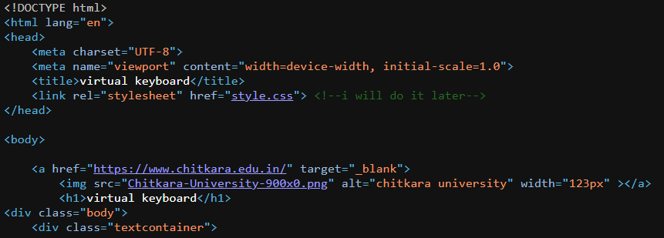

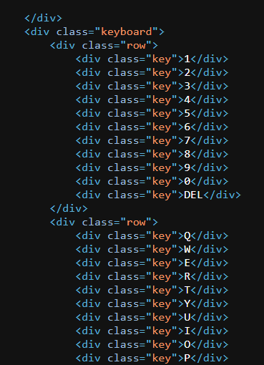

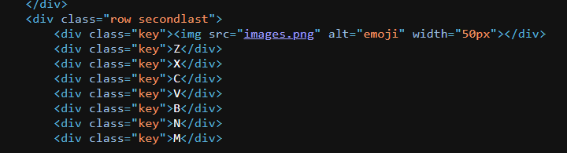

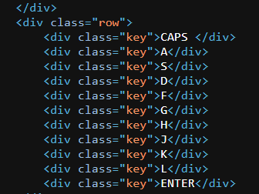

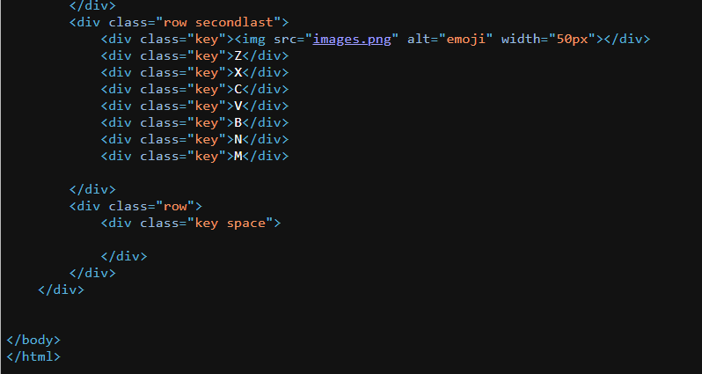

**Output:-**

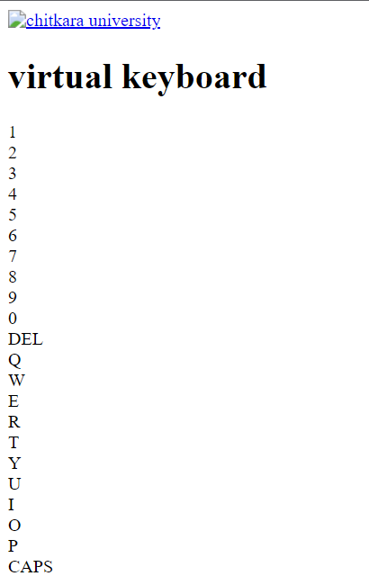

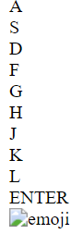

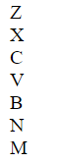

**CSS Code:-**

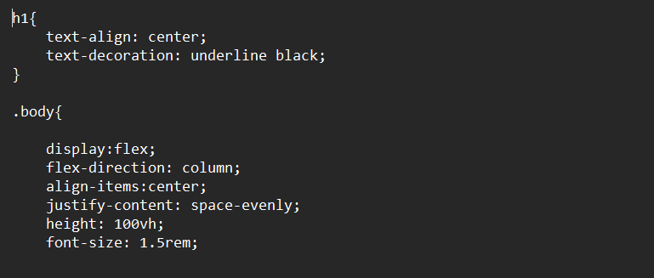

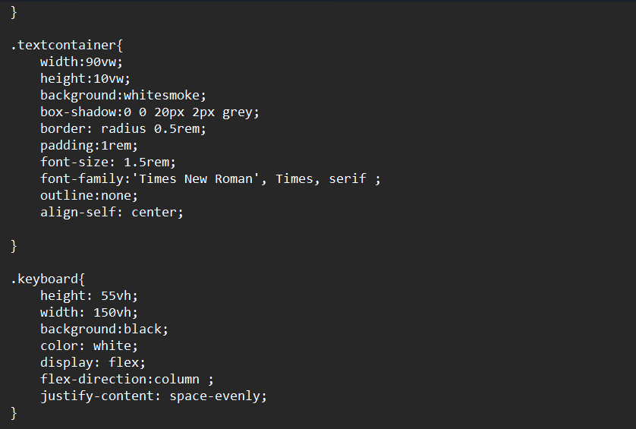

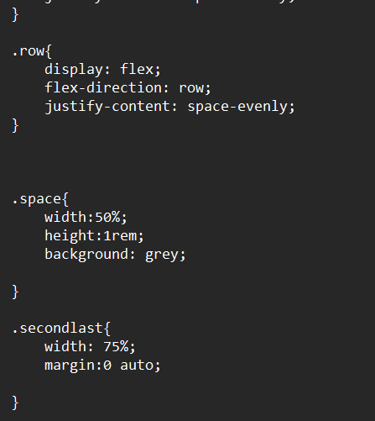

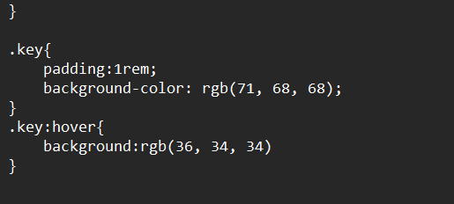

**After compiling both Html and CSS**

**Output:-**

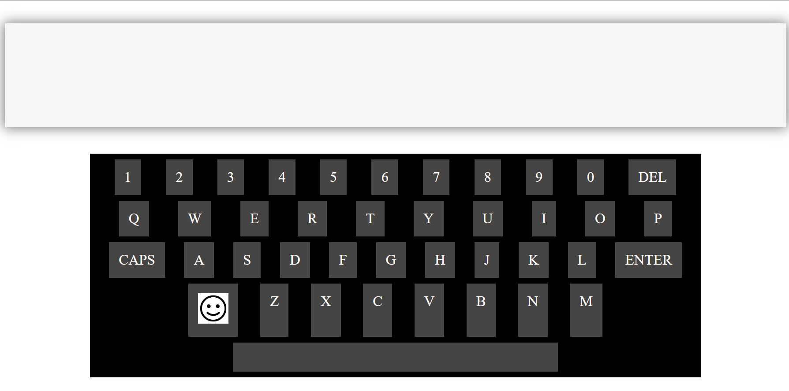

**6. Conclusion:-**

Creating a virtual keyboard using HTML and CSS was a Great learning experience.

Through this project, we gained a deeper understanding of web development, particularly

in designing user interfaces and incorporating interactivity into a webpage.

Overall, this project not only helped us apply theoretical knowledge but also sharpened

our problem-solving skills, teamwork abilities and project management capabilities. It

served as a practical demonstration of web development concepts and significantly

contributed to my growth as a web developer.